Pushdown Automata(PDA)

* Pushdown automata is a way to implement a CFG in the same way we design DFA for a regular grammar. A DFA can remember a finite amount of information, but a PDA can remember an infinite amount of information.
* Pushdown automata is simply an NFA augmented with an "external stack memory". The addition of stack is used to provide a last-in-first-out memory management capability to Pushdown automata. Pushdown automata can store an unbounded amount of information on the stack. It can access a limited amount of information on the stack. A PDA can push an element onto the top of the stack and pop off an element from the top of the stack. To read an element into the stack, the top elements must be popped off and are lost.
* A PDA is more powerful than FA. Any language which can be acceptable by FA can also be acceptable by PDA. PDA also accepts a class of language which even cannot be accepted by FA. Thus PDA is much more superior to FA.

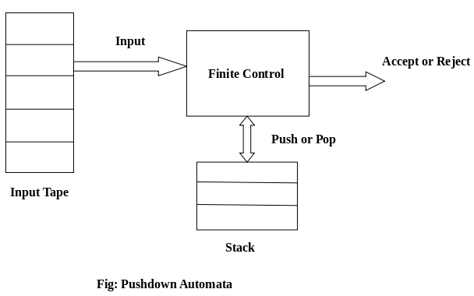

PDA Components:

**Input tape:** The input tape is divided in many cells or symbols. The input head is read-only and may only move from left to right, one symbol at a time.

**Finite control:** The finite control has some pointer which points the current symbol which is to be read.

**Stack:** The stack is a structure in which we can push and remove the items from one end only. It has an infinite size. In PDA, the stack is used to store the items temporarily.

Formal definition of PDA:

The PDA can be defined as a collection of 7 components:

**Q:** the finite set of states

**∑:** the input set

**Γ:** a stack symbol which can be pushed and popped from the stack

**q0:** the initial state

**Z:** a start symbol which is in Γ.

**F:** a set of final states

**δ:** mapping function which is used for moving from current state to next state.

Instantaneous Description (ID)

ID is an informal notation of how a PDA computes an input string and make a decision that string is accepted or rejected.

**An instantaneous description is a triple (q, w, α) where:**

**q** describes the current state.

**w** describes the remaining input.

**α** describes the stack contents, top at the left.

Turnstile Notation:

⊢sign describes the turnstile notation and represents one move.

⊢* sign describes a sequence of moves.

**For example,**

(p, b, T) ⊢ (q, w, α)

In the above example, while taking a transition from state p to q, the input symbol 'b' is consumed, and the top of the stack 'T' is represented by a new string α.

**Pushdown Automata**

A Pushdown Automata (PDA) can be defined as :

* Q is the set of states
* ∑is the set of input symbols
* Γ is the set of pushdown symbols (which can be pushed and popped from the stack)
* q0 is the initial state
* Z is the initial pushdown symbol (which is initially present in the stack)
* F is the set of final states
* δ is a transition function that maps Q x {Σ ∪ ∈} x Γ into Q x Γ*. In a given state, the PDA will read the input symbol and stack symbol (top of the stack) move to a new state, and change the symbol of the stack.

**Instantaneous Description (ID)**

Instantaneous Description (ID) is an informal notation of how a PDA “computes” an input string and makes a decision whether that string is accepted or rejected.

An ID is a triple (q, w, α), where:   
1. q is the current state.   
2. w is the remaining input.   
3.α is the stack contents, top at the left.

**Turnstile Notation**

⊢ sign is called a “turnstile notation” and represents   
one move.   
⊢* sign represents a sequence of moves.   
Eg- (p, b, T) ⊢ (q, w, α)   
This implies that while taking a transition from state p to state q, the input symbol ‘b’ is consumed, and the top of the stack ‘T’ is replaced by a new string ‘α’

**Example :** Define the pushdown automata for language {anbn | n > 0}   
**Solution :**M = where Q = { q0, q1 } and Σ = { a, b } and Γ = { A, Z } and δ is given by :

δ( q0, a, Z ) = { ( q0, AZ ) }   
δ( q0, a, A) = { ( q0, AA ) }   
δ( q0, b, A) = { ( q1, ∈) }   
δ( q1, b, A) = { ( q1, ∈) }   
δ( q1, ∈, Z) = { ( q1, ∈) }

Let us see how this automata works for aaabbb.

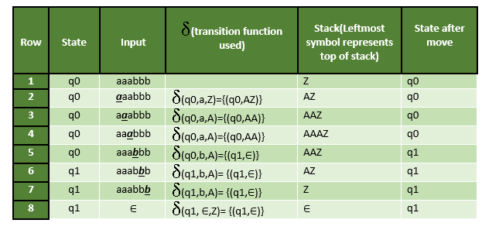

Example 1:

Design a PDA for accepting a language {anb2n | n>=1}.

**Solution:** In this language, n number of a's should be followed by 2n number of b's. Hence, we will apply a very simple logic, and that is if we read single 'a', we will push two a's onto the stack. As soon as we read 'b' then for every single 'b' only one 'a' should get popped from the stack.

The ID can be constructed as follows:

1. δ(q0, a, Z) = (q0, aaZ)
2. δ(q0, a, a) = (q0, aaa)

Now when we read b, we will change the state from q0 to q1 and start popping corresponding 'a'. Hence,

1. δ(q0, b, a) = (q1, ε)

Thus this process of popping 'b' will be repeated unless all the symbols are read. Note that popping action occurs in state q1 only.

1. δ(q1, b, a) = (q1, ε)

After reading all b's, all the corresponding a's should get popped. Hence when we read ε as input symbol then there should be nothing in the stack. Hence the move will be:

1. δ(q1, ε, Z) = (q2, ε)

Where

PDA = ({q0, q1, q2}, {a, b}, {a, Z}, δ, q0, Z, {q2})

We can summarize the ID as:

1. δ(q0, a, Z) = (q0, aaZ)
2. δ(q0, a, a) = (q0, aaa)
3. δ(q0, b, a) = (q1, ε)
4. δ(q1, b, a) = (q1, ε)
5. δ(q1, ε, Z) = (q2, ε)

Now we will simulate this PDA for the input string "aaabbbbbb".

1. δ(q0, aaabbbbbb, Z) ⊢ δ(q0, aabbbbbb, aaZ)
2. ⊢ δ(q0, abbbbbb, aaaaZ)
3. ⊢ δ(q0, bbbbbb, aaaaaaZ)
4. ⊢ δ(q1, bbbbb, aaaaaZ)
5. ⊢ δ(q1, bbbb, aaaaZ)
6. ⊢ δ(q1, bbb, aaaZ)
7. ⊢ δ(q1, bb, aaZ)
8. ⊢ δ(q1, b, aZ)
9. ⊢ δ(q1, ε, Z)
10. ⊢ δ(q2, ε)
11. ACCEPT

Non-deterministic Pushdown Automata

The non-deterministic pushdown automata is very much similar to NFA. We will discuss some CFGs which accepts NPDA.

The CFG which accepts deterministic PDA accepts non-deterministic PDAs as well. Similarly, there are some CFGs which can be accepted only by NPDA and not by DPDA. Thus NPDA is more powerful than DPDA.

Example:

Design PDA for Palindrome strips.

**Solution:**

PauseNext

Unmute

Current TimeÂ 0:10

/

DurationÂ 18:10

Loaded: 4.77%

Â

Fullscreen

Suppose the language consists of string L = {aba, aa, bb, bab, bbabb, aabaa, ......]. The string can be odd palindrome or even palindrome. The logic for constructing PDA is that we will push a symbol onto the stack till half of the string then we will read each symbol and then perform the pop operation. We will compare to see whether the symbol which is popped is similar to the symbol which is read. Whether we reach to end of the input, we expect the stack to be empty.

This PDA is a non-deterministic PDA because finding the mid for the given string and reading the string from left and matching it with from right (reverse) direction leads to non-deterministic moves. Here is the ID.

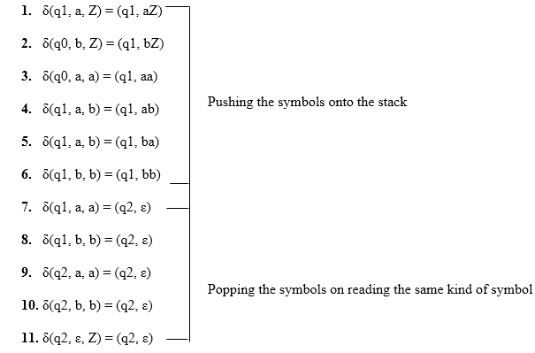

**Simulation of abaaba**

1. δ(q1, abaaba, Z)            Apply rule 1
2. ⊢ δ(q1, baaba, aZ)          Apply rule 5
3. ⊢ δ(q1, aaba, baZ)          Apply rule 4
4. ⊢ δ(q1, aba, abaZ)          Apply rule 7
5. ⊢ δ(q2, ba, baZ)            Apply rule 8
6. ⊢ δ(q2, a, aZ)              Apply rule 7
7. ⊢ δ(q2, ε, Z)               Apply rule 11
8. ⊢ δ(q2, ε)                  Accept

CFG to PDA Conversion

The first symbol on R.H.S. production must be a terminal symbol. The following steps are used to obtain PDA from CFG is:

**Step 1:** Convert the given productions of CFG into GNF.

**Step 2:** The PDA will only have one state {q}.

**Step 3:** The initial symbol of CFG will be the initial symbol in the PDA.

**Step 4:** For non-terminal symbol, add the following rule:

1. δ(q, ε, A) = (q, α)

Where the production rule is A → α

**Step 5:** For each terminal symbols, add the following rule:

1. δ(q, a, a) = (q, ε) **for** every terminal symbol

Example 1:

Convert the following grammar to a PDA that accepts the same language.

1. S → 0S1 | A
2. A → 1A0 | S | ε

**Solution:**

The CFG can be first simplified by eliminating unit productions:

1. S → 0S1 | 1S0 |  ε

Now we will convert this CFG to GNF:

1. S → 0SX | 1SY |  ε
2. X → 1
3. Y → 0

The PDA can be:

**R1:**δ(q, ε, S) = {(q, 0SX) | (q, 1SY) | (q, ε)}

**R2:**δ(q, ε, X) = {(q, 1)}

**R3:**δ(q, ε, Y) = {(q, 0)}

**R4:**δ(q, 0, 0) = {(q, ε)}

**R5:**δ(q, 1, 1) = {(q, ε)}

Example 2:

Construct PDA for the given CFG, and test whether 0104 is acceptable by this PDA.

1. S → 0BB
2. B → 0S | 1S | 0

**Solution:**

The PDA can be given as:

1. A = {(q), (0, 1), (S, B, 0, 1), δ, q, S, ?}

The production rule δ can be:

**R1:**δ(q, ε, S) = {(q, 0BB)}

**R2:**δ(q, ε, B) = {(q, 0S) | (q, 1S) | (q, 0)}

**R3:**δ(q, 0, 0) = {(q, ε)}

**R4:**δ(q, 1, 1) = {(q, ε)}

Testing 0104 i.e. 010000 against PDA:

1. δ(q, 010000, S) ⊢ δ(q, 010000, 0BB)
2. ⊢ δ(q, 10000, BB)              R1
3. ⊢ δ(q, 10000,1SB)              R3
4. ⊢ δ(q, 0000, SB)               R2
5. ⊢ δ(q, 0000, 0BBB)             R1
6. ⊢ δ(q, 000, BBB)               R3
7. ⊢ δ(q, 000, 0BB)               R2
8. ⊢ δ(q, 00, BB)                 R3
9. ⊢ δ(q, 00, 0B)                 R2
10. ⊢ δ(q, 0, B)                   R3
11. ⊢ δ(q, 0, 0)                   R2
12. ⊢ δ(q, ε)                      R3
13. ACCEPT

Thus 0104 is accepted by the PDA.

Example 3:

Draw a PDA for the CFG given below:

1. S → aSb
2. S → a | b | ε

**Solution:**

The PDA can be given as:

1. P = {(q), (a, b), (S, a, b, z0), δ, q, z0, q}

The mapping function δ will be:

**R1:**δ(q, ε, S) = {(q, aSb)}

**R2:**δ(q, ε, S) = {(q, a) | (q, b) | (q, ε)}

**R3:**δ(q, a, a) = {(q, ε)}

**R4:**δ(q, b, b) = {(q, ε)}

**R5:**δ(q, ε, z0) = {(q, ε)}

**Simulation:** Consider the string aaabb

1. δ(q, εaaabb, S) ⊢ δ(q, aaabb, aSb)             R3
2. ⊢ δ(q, εaabb, Sb)              R1
3. ⊢ δ(q, aabb, aSbb)             R3
4. ⊢ δ(q, εabb, Sbb)              R2
5. ⊢ δ(q, abb, abb)               R3
6. ⊢ δ(q, bb, bb)                 R4
7. ⊢ δ(q, b, b)                   R4
8. ⊢ δ(q, ε, z0)                  R5
9. ⊢ δ(q, ε)
10. ACCEPT